*Name:
*Registration:

Department of Computer Systems Engineering University of Engineering & Technology Peshawar

Digital System Design
CSE 308

Midterm Examination Spring 2023
13 April 2023, Duration: 120 Minutes

**Exam Rules**
Please read carefully before proceeding.
- This exam is closed books/notes/Internet.
- Answer all problems on the answer sheet.
- Problems will not be interpreted during the exam.

Good Luck!

Problem 1. (25 pts.)
Below is an RTL (or Dataflow) description for a circuit.
module RTL_circuit (x, y, a, b, c);

input a, b, c;
output x, y;
wire a, b, c, x, y;
wire na, nb, nc, t3, t4, t5;

assign na = !a; assign nb = !b; assign nc = !c;
assign t3 = na && b && c;
assign t4 = a && nb && c;
assign t5 = a && b && nc;
assign x = t3 || t5;
assign y = a || t4;

endmodule

1(a) (3 pts.) Give a Verilog statement that instantiates the above RTL_circuit, with the instance name MID. When you instantiate the circuit, use the same names for wires as is used in the module port list.

Solution:

RTL_circuit MID (x, y, a, b, c);

1(b) (6 pts.) Rewrite the RTL_circuit using Verilog built-in primitives and structural Verilog. Part of the module is done for you.

module struct_circuit (x, y, a, b, c);

input a, b, c;
output x, y;
//Write your code here

endmodule

Solution:

module struct_circuit (x, y, a, b, c);

input a, b, c;
output x, y;
//Write your code here
wire a, b, c, x, y;
wire na, nb, nc, t3, t4, t5;
not n1(na, a);
not n2(nb, b);
not n3(nc, c);
and a1(t3, na, b, c);
and a2(t4, a, nb, c);
and a3(t5, a, b, nc);
or o1(x, t3, t5);
or o2(y, a, t4);

endmodule

1(c) (3 pts.) Draw a gate-level diagram for your module in 1(b). Label all nets on the diagram.

Solution:

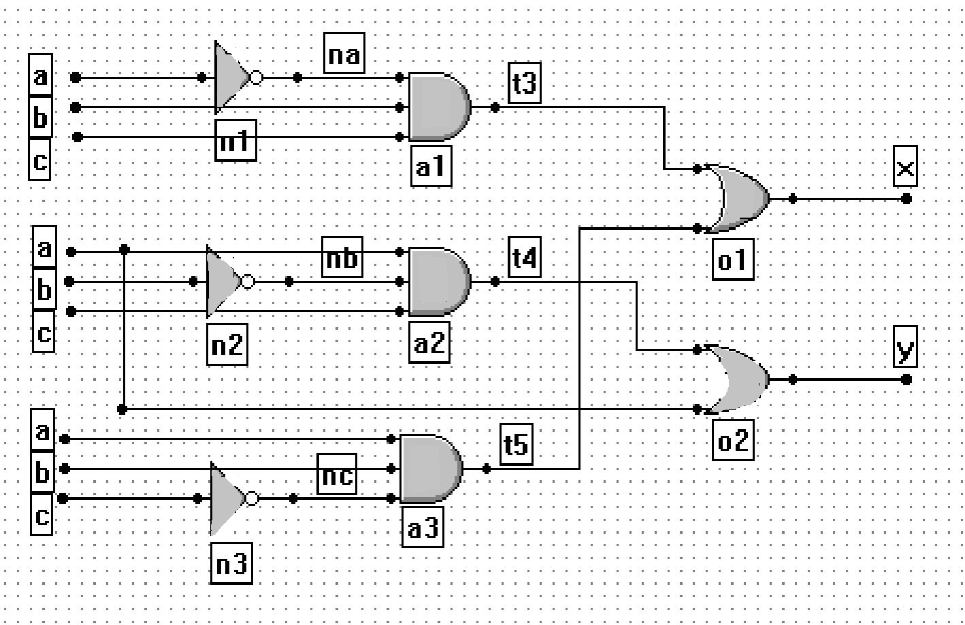

1(d) (6 pts.) Rewrite the RTL_circuit using behavioral Verilog. Part of the module is done for you.
module behav_circuit (x, y, a, b, c);

input a, b, c;
output x, y;
//Write your code here

endmodule

Solution:

module behav_circuit (x, y, a, b, c);

input a, b, c;
output x, y;
//Write your code here
wire a, b, c;
reg x, y;
reg t3, t4, t5;
always @( a or b or c ) t3 <= !a & b & c;
always @( a or b or c ) t4 <= a & !b & c;
always @( a or b or c ) t5 <= a & b & !c;
always @( t3 or t5 ) x <= t3 | t5;
always @( a or t4 ) y <= a | t4;

endmodule

1(e) (7 pts.) Write the output of RTL_circuit for the following test bench.
//test bench for RTL_circuit
module test_RTL_circuit;

reg a, b, c;
wire x, y;

RTL_circuit RTLC (x, y, a, b, c);

Initial begin
a = 1; b = 1; c = 1;
#30 a = 0; b = 1; c = 1;
end

initial begin
$display ($time, " x = %b and y = %b", x, y);
#6 $display ($time, " x = %b and y = %b", x, y);
#5 $display ($time, " x = %b and y = %b", x, y);
#20 $display ($time, " x = %b and y = %b", x, y);
#5 $display ($time, " x = %b and y = %b", x, y);
#6 $display ($time, " x = %b and y = %b", x, y);
#8 $display ($time, " x = %b and y = %b", x, y);
end

endmodule

Solution:

0 x = 0 and y = 1
6 x = 0 and y = 1
11 x = 0 and y = 1
31 x = 1 and y = 0
36 x = 1 and y = 0
42 x = 1 and y = 0

50 x = 1 and y = 0

Problem 2. (10 pts.)
In this problem, design a 3-bit counter (the circuit diagram and state table are shown in Figure 1) using as building block the D flip-flop given in Figure 2.
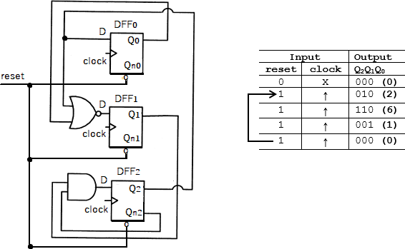

Figure 1. The circuit diagram (left) and state table (right) of the 3-bit counter
module DFF (D, clock, reset, Q, Qn);

input D; // Data input input clock; // Clock input
input reset; // Asynchronous active-low reset output Q, Qn; // Outputs Q and Q'
reg Q;

always @ (posedge clock or negedge reset) if (reset==1'b0)
Q <= 0;
else
Q <= D;

assign Qn = ~Q; endmodule
Figure 2. Verilog code for rising-edge D flip-flop with asynchronous active-low reset

The suggested skeleton file for the counter has been written below. The module has 2 inputs – clock and reset which is active-low. The output is out which is 3-bit in size.
module counter (clock, reset, out);

input clock, reset; output [2:0] out;
// Write your code here

endmodule

Solution:

module counter (clock, reset, out);

input clock, reset; output [2:0] out;
// Write your code here
wire [2:0] Qn;

DFF dff0 (out[2], clock, reset, out[0], Qn[0]);
DFF dff1 (~(out[0]|out[2]), clock, reset, out[1], Qn[1]);
DFF dff2 (out[1]& Qn[2], clock, reset, out[2], Qn[2]);

endmodule

Problem 3. (10 pts.)
In this problem, write Verilog code for an 8-to-1 multiplexer. In this case, the value on the 3-bit select line will route 1 of 8 inputs to the output. This module is purely combinatorial.

The following are the ports of the module:
Sel | 3-bit select line
I0, I1, I2, I3, I4, I5, I6, and I7 | 1-bit data inputs
OUT | 1-bit output

Solution:

module m81 (OUT, I0, I1, I2, I3, I4, I5, I6, I7, Sel);

input I0, I1, I2, I3, I4, I5, I6, I7;
input [2:0] Sel;
output OUT;
reg OUT;

always @(*)
case (Sel)
0: OUT=I0;
1: OUT=I1;
2: OUT=I2;
3: OUT=I3;
4: OUT=I4;
5: OUT=I5;
6: OUT=I6;
7: OUT=I7;
endcase

endmodule

Problem 4. (10 pts.)
For this design, combine the counter (from Problem 2) with the multiplexer (from Problem 3) to create a circuit such that the output of the counter controls the select lines of the multiplexer.

This top-level design has the following port definitions:
clk | 1-bit clock
reset | 1-bit reset line
D0, D1, D2, D3, D4, D5, D6, and D7 | 1-bit data inputs
OUT | 1-bit output

Solution:
module top (OUT, clk, reset, D0, D1, D2, D3, D4, D5, D6, D7);

input clk, reset, D0, D1, D2, D3, D4, D5, D6, D7;
output OUT;

wire [2:0] out;

counter c (clk, reset, out);
m81 m (OUT, D0, D1, D2, D3, D4, D5, D6, D7, out);

endmodule

